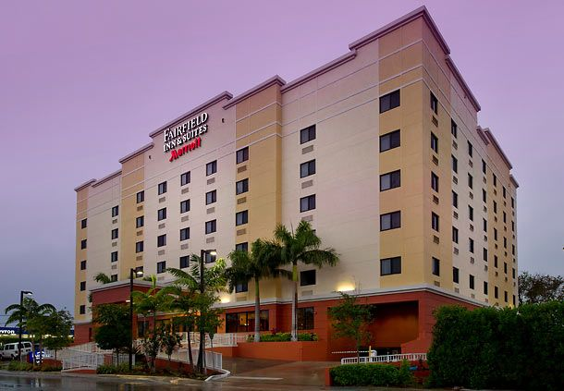

Fairfield Inn & Suites Miami Airport South
4101 NW 11th Street
Miami, FL 33126
Tel: 786-456-2100

Directions:
I-95 South, merge onto SR-836 W via exit 3A toward Miami Int’l Airport, take the N.W. 42nd Ave. S/Le Jeune Rd exit on the left, turn left onto NW 11th Street, 4101 NW 11th Street is on the left.

