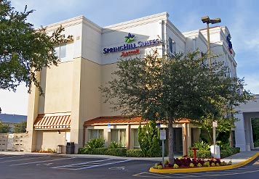

Springhill Suites Orlando Altamonte Springs/Maitland
205 W. Highway 436
Altamonte Springs, Florida 32714
Phone: 1-407-865-6400

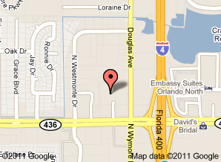

Directions:
I-4 East to Exit 92 Altamonte Springs, turn left onto Semoran Blvd. (SR 436), turn right just after Douglas Ave-Hotel on the right just before the Perkins restaurant.

I-4 West to Exit 92 Altamonte Springs, turn right onto Semoran Blvd. (SR 436), turn right just after Douglas Ave-Hotel on the right just before the Perkins restaurant.

