

Springhill Suites Tallahassee Central
1300 Executive Center Drive
Tallahassee, Florida 32301
Phone: 1-850-325-1103

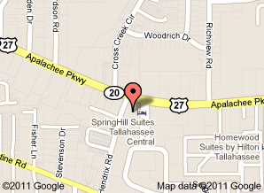

Directions:
Start out going East on US-27/FL20/APALACHEE PKWY toward 319 CAPITAL CIR 0.5 mi. Turn RIGHT onto CAPITAL CIR SE/US-319S/FL-261S. Continue to follow CAPITAL CIR SE. 10.8 mi END at 3300 CAPITAL CIR SW Tallahassee, FL 32310.

