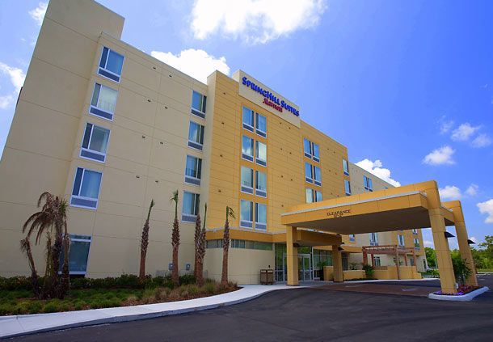

Springhill Suites by Marriott Tampa Palms/I-75 Tampa North
5396 Primrose Lake Circle
Tampa, Florida 33647
Tel: 1-813-558-0300

Directions:
I-4 West, merge onto I-75 N via Exit 9 toward Ocala/Temple Terrace. Take the CR-581 South Exit, Exit 270. Turn left onto Bruce B. Downs Blvd, Turn right onto Tampa Palms Blvd. West.
Take the 2nd right onto Commerce Park Blvd., Turn right onto Primrose Lake Cir, Hotel is on the right.

